 | 10.1.6 Editors - Compositor Editor - Header - Add Menu - Input - Constant
Table of content
Detailed table of content 1
Add menu - Input - Constant 3
Boolean 3
Color 3
Integer 3
Normal 4
Value 4
Vector 4

Detailed table of content

Detailed table of content
Detailed table of content 1
Add menu - Input - Constant 3
Boolean 3
Properties 3
Boolean 3
Outputs 3
Boolean 3
Color 3
Properties 3
Outputs 3
Color / RGBA 3
Integer 3
Properties 3
Integer 3
Outputs 4
Integer 4
Normal 4
Properties 4
Input Value 4
Outputs 4
Normal 4
Value 4
Properties 4
Value 4
Outputs 4
Value 4
Vector 4
Properties 4
Vector 4
Outputs 5
Vector 5

Add menu - Input - Constant
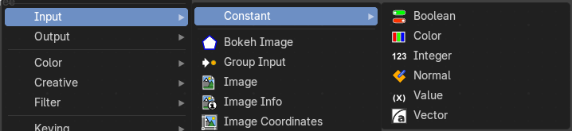

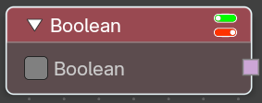
Boolean
Provide a true / false value.

Properties

Boolean
The boolean toggle.

Outputs

Boolean
The state of the toggle.

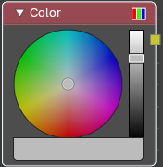
Color
Set a color.

Properties
The RGB node uses the color picker widget.

Outputs

Color / RGBA
A single RGBA color value.

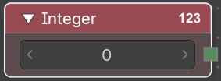
Integer
Provides an integer value.

Properties

Integer
The value.

Outputs

Integer
The output value.

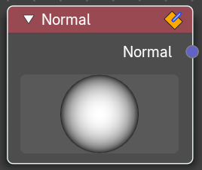
Normal
Input normalized normal values to the other nodes in the tree.

Properties

Input Value
Here you can adjust the directory of the light to see how the normals behaves.

Outputs

Normal
The output value.

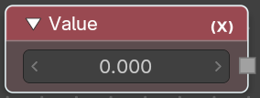
Value
Provides a float value.

Properties

Value
The float value.

Outputs

Value
The output value.

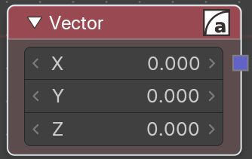
Vector
Provides a vector 3 value.

Properties

Vector
The single values of the vector 3.

Outputs

Vector
The output vector.

